Market Expansion Pipeline Documentation
1. Executive Summary
The Market Expansion Pipeline is a data-driven framework designed to identify high-potential global cities for new retail locations. It moves beyond historical sales analysis by integrating macroeconomic indicators (GDP, Population, Internet Adoption) to calculate untapped market potential and provide a realistic, phased store-opening schedule.
2. Data Architecture & Feature Engineering
The pipeline aggregates transaction-level data to a City-Level Dimension. Key engineered features include:
- Market Penetration: Calculated as $\frac{\text{Sales Amount}}{\text{Population}}$. This serves as the "Saturation Metric." High penetration indicates a mature market; low penetration indicates an untapped opportunity.
- Normalized Metrics: Using MinMaxScaler, we normalize GDP, Population, and Penetration to a 0.1 scale to ensure features with different units can be compared fairly.
- Market Priority Index (MPI): A weighted heuristic score:
  - 40% GDP per Capita: Measures purchasing power.
  - 40% Population: Measures the total addressable market size.
  - -20% Penetration: Penalizes cities where the brand is already heavily present to avoid cannibalization.
3. The Machine Learning Model
We utilize a Random Forest Classifier to categorize cities into expansion priority levels.
Model Logic:
- Target Variable: expansion_priority (Binary).
  - 1 (High Priority): Cities above the median for GDP and Population, but below the median for Penetration.
  - 0 (Low Priority): Cities that are either too small, have low purchasing power, or are already saturated.
- Performance: The model achieves ~93% accuracy, with high precision for identifying expansion targets, ensuring that capital is not wasted on low-potential zones.
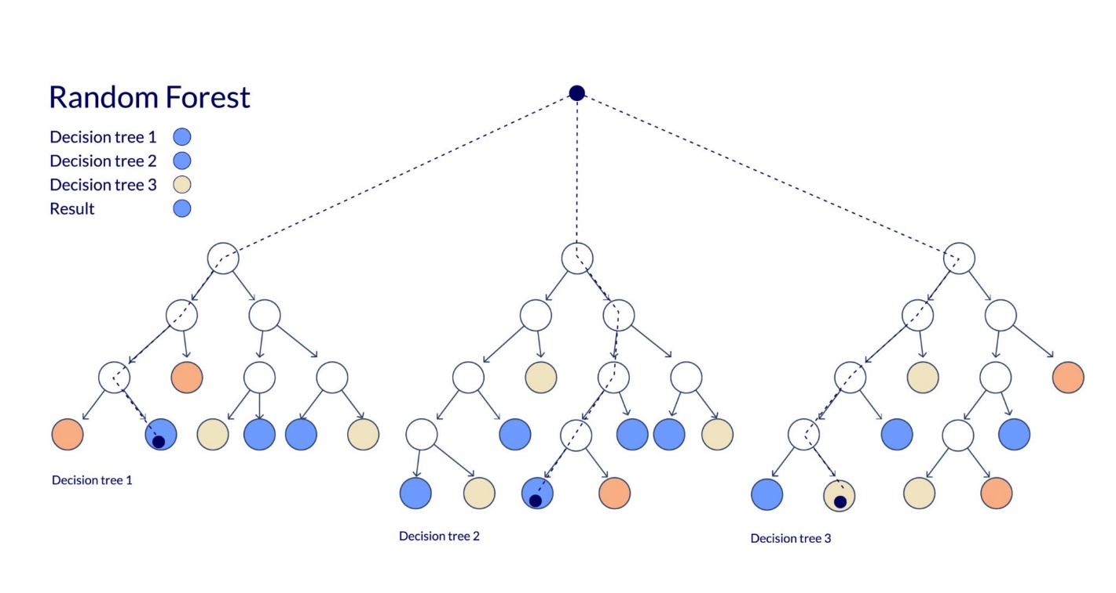

4. Realistic Expansion Logic (Phase 1)
To prevent mathematically valid but operationally impossible recommendations (e.g., opening 30 stores at once), the pipeline applies a Constraint-Based Growth Function:
- Ideal Capacity: Calculated as 1 store per 2,000,000 people.
- Growth Cap: Expansion for any single city is limited to the minimum of:
  - The raw gap (Ideal - Current).
  - $50\%$ of the current store count.
  - A hard cap of 5 stores per phase.
5. Strategic Recommendations by Segment
Tier 1: Aggressive Growth (The "Mega-Gap" Cities)
- Characteristics: Massive population, high GDP, but very low current store count.
- Primary Targets: Tokyo, Shanghai, Beijing, Mexico City.
- Action: Immediate Phase 1 rollout (+3 to +5 stores) and establishment of local logistics hubs.

Tier 2: Premium Scaling (The "Wealth" Cities)
- Characteristics: High GDP per capita and high internet usage.
- Primary Targets: Seoul, London, Paris, Hong Kong.
- Action: Focus on "Experience Centers" and high-street locations to increase penetration among the wealthy demographic.
Tier 3: Market Maintenance (The "Saturated" Cities)
- Characteristics: High penetration and established presence.
- Primary Targets: Chicago, New York, Amsterdam.
- Action: Focus on e-commerce fulfillment and store efficiency rather than new physical footprints.
6. Risk Mitigations
- Economic Volatility: The pipeline utilizes the inflation_rate and exchange_rate features to adjust "Realistic Sales."
- Digital Displacement: In cities with $>90\%$ internet_usage_pct, the physical store recommendation should be supplemented with a strong digital marketing spend.

